**LAB 9**

**MAC ADDRESS TABLES**

In this lab you learn how to work with MAC address tables.

1. Download and open the file “Lab 09 – MAC Address Tables.pka”.

This file contains the following network:

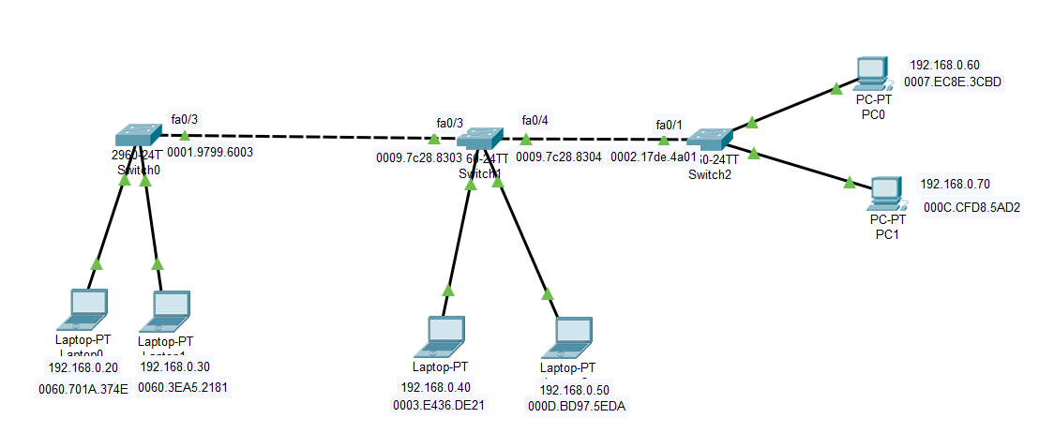

1. In what layer of the OSI model can the switches be located in this network?(name + No)

2nd layer: datalink

1. Use an IOS command on Switch0 to obtain L1/2 information about the interface connected to laptop0.

To get local access to the IOS CLI, remember you’ll have to make an additional connection using a special cable…

Show interfaces fa0/1

Hint: to do this, use the ***show interfaces*** command**,**where you explicitly mention the name of the desired interface behind this command.

Take a good look at the output of this command and enter the following information about the interface:

**Mac address =** 0001.9799.6001

**Bandwidth in Mbps** = 100Mbps

**Half or Full Duplex?** Full duplex

Note that the MAC address in the output of your command is indicated by the letter word BIA. What does this abbreviation stand for?

Burned In Address

1. Type in the previous command again, but without explicitly mentioning an interface, to see all the L1/L2 info from all interfaces of the switch.

Show interfaces

1. That information is quite a lot. Now only request a status overview of all interfaces by using ‘status’ as extra parameter to the previous command.

Hint: if it doesn’t work, remember that some commands/parameters are only possible in certain ‘modes’ of IOS (User EXEC, Privileged EXEC, etc.)

Show interfaces status

What interesting information does this command show?

We can see if an interface is connected.

1. Using an IOS command, request the contents of the MAC address table from Switch0.

Show mac address-table

You will find that the MAC address table of that switch contains exactly one MAC address. Which interface (port and switch) corresponds to that MAC address?

Port fa0/3

Explain why that particular port is in the MAC address table.

This port is used to connect the switch to Switch0

1. Now, request the contents of the MAC address table from Switch0 via the GUI.

Hint: click on the switch using the “Inspect” tool (magnifier icon)

You’ll find the same information as in the previous question. Also have a look at the MAC Address Tables of the other switches via the GUI. How many entries does each table have?

**Number of MAC addresses in the MAC address table of Switch0 = 3**

**Number of MAC addresses in the MAC address table of Switch1 = 4**

**Number of MAC addresses in the MAC address table of Switch2 = 3**

1. Ping from laptop0 to PC0 and note below how many MAC addresses are now in the MAC address tables of the switches.

**Number of MAC addresses in the MAC address table of Switch0 = 5**

**Number of MAC addresses in the MAC address table of Switch1 = 6**

**Number of MAC addresses in the MAC address table of Switch2 = 5**

Which interfaces correspond to the MAC addresses in the MAC address table of Switch1?

* Laptop0’s NIC
* PC0’s NIC
* Interface fa0/3 – Switch0
* Interface fa0/1 – Switch2

Predict how many MAC addresses will be in the MAC address tables of the switches after you ping from laptop1 to PC1.

**Number of MAC addresses in the MAC address table of Switch0 = 5**

**Number of MAC addresses in the MAC address table of Switch1 = 6**

**Number of MAC addresses in the MAC address table of Switch2 = 5**

Now check that your prediction is correct by effectively pinging from laptop1 to PC1.

1. Note that the MAC addresses automatically disappear from the MAC address tables over time (5 minutes).

However, you can delete the contents of the MAC address table at any time using **the clear command**.

Test this in the IOS CLI on Switch0 and check that the MAC address table is indeed empty.

clear mac-address-table

show mac-address-table

Note that the MAC address tables are never completely empty for long and will very quickly contain the MAC addresses of the interfaces of the switches to which they are connected (because switches communicate also with each other via other protocols).